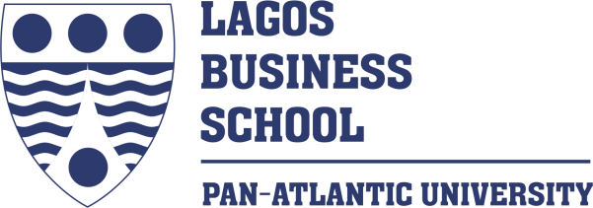
Kleos Africa
Rev. Month Day, Year
CASE CODE
XXXXXXXXX
XXXXXXXXX

Copyright © 2022, Lagos Business School. This publication was developed through field research. No part of this publication may be reproduced, stored in a retrieval system, used in a spreadsheet, or transmitted in any form or by any means – electronic, mechanical, photocopying, recording, or otherwise – without the written permission of Lagos Business School.
XXX-XXX-XXX and XXX-XXX-XXX prepared this case as the basis for class discussion rather than to illustrate either effective or ineffective handling of an administrative situation.
The authors hereby acknowledge the contributions of XXX-XXX for her insights while writing this case.

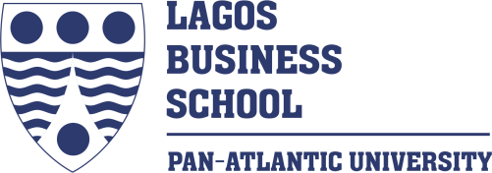
Kleos Africa
Case Code
It was a rainy day in February 2021. Glory Enyinnaya watched as her driver manoeuvred to the next lane on a busy road in Lagos, Nigeria, as other road users blocked some streets to avoid traffic congestion. Glory had some other issues on her mind despite the seeming chaos on the road. She picked up a report by her side and contemplated the web page displaying the most recent data analytics reports of her start-up’s online consulting platform, Kleos Africa. She shut her MacBook Air with mixed feelings at the sound of a loud blaring horn from an old Hilux van by the side of her car. Despite substantial investment in her start-up company, Kleos Africa’s digital marketing infrastructure, such as email marketing automation software, regular social media advertisements and a dedicated marketing manager, the conversion rates were still far from the global benchmarks of 30 to 60% required to achieve scalability and growth for platform companies like hers. Her major concern was how to plan and launch a conversion optimisation campaign on the company’s site over an initial period of 4 months and achieve a conversion rate of 20% or more, thus significantly increasing the revenue. How can she get more clients in a vibrant country with millions of SMEs who may require her services? Would this solution be able to elicit Kleos’ market requirements with its operations’ competitive priorities of cost, quality, speed, and flexibility?

Kleos Company
Kleos Africa, a pioneer online consulting platform, was established in 2017 by Glory Enyinnaya, an experienced management consultant, while studying for an Executive MBA at Lagos Business School. During the MBA program, she stumbled on a study conducted by the Global Entrepreneurship Monitor in 2015, which indicated that Nigeria led the world in enthusiasm for business and had a substantial number of people living in extreme poverty. These two facts pointed to an opportunity to bridge the gap between the desire of many Africans to start a business and the acumen required to build a sustainable business.
Kleos Africa’s value proposition was providing affordable management consulting services to African SMEs at a much higher quality and much lower cost than consulting firms such as KPMG, Price Waterhouse Coopers and Deloitte. By providing affordable consulting services, Kleos Africa envisioned a future where SMEs would rise above the level of subsistence businesses and build truly transformational enterprises. Kleos Africa made money by charging a 20% commission on all projects on the platform. The platform offers business clinics, digital marketing, business plan development, management consulting, training, mentoring, coaching, and capital raising services through its online platform. Some of these services were subsidised by the company’s strategic partners and therefore provided for free for beneficiaries. For other services, the price was determined by considering market rates, the solution’s value to the client and the client’s ability to pay. The platform avoided disintermediation by offering an ‘’escrow’’ or ‘’delayed pay-out’’ service. Upon initiating a new project, it captured the payment from the client and notified the consultant but did not move the money to the consultant before completing the service in question. By acting as an agent, the client and the consultant were protected from the risk of default. They also offered clients the option of booking a new consultant at no extra cost in cases where the provided service did not meet the client’s needs or expectations.
Kleos Operations
Kleos Africa’s operations can be classified as primary (directly creating value for its customers) and support necessary to maintain and strengthen the primary processes (Exhibit 7). Primary processes were marketing, lead generation, sales and lead conversion, project delivery (design, data collection, data analysis and generation of advisory solution for the client), implementation assistance and client relationship management. Support processes are the recruitment of consultants and support personnel, knowledge management and technology development. In conducting its operations, Kleos Africa partnered with several organisations along the value chain. Some of these partners included commercial banks, fintech companies, business accelerators and incubators, multinational consulting firms, software companies, venture capital firms, financial advisory firms, microfinance institutions and several other players in the entrepreneurial ecosystem. These partners cooperated, collaborated and coordinated the execution of key processes such as generating and converting potential customers or beneficiaries. The partnerships were governed by written agreements which formalised the value exchange relationship. The flow of information, products and processes within Kleos Africa and with partners or others in its enabling ecosystem can be depicted in its value chain (Exhibit 6). Cost drivers included fees to consultants, technology development and maintenance costs, marketing, payroll, research, audit and administrative expenses. Kleos Africa had identified the key programs - activities, innovations, processes and initiatives - which it needed to undertake to achieve its social innovation outcomes and impact at a cost that was affordable to underserved markets (SMEs) and at a scale that was aligned to the size of the opportunity (Exhibit 1). Some of its strategies included establishing strategic partnerships with banks and fintech companies that provided SMEs access to finance. These partnerships helped Kleos to locate SMEs and provided them with consulting services. Other strategies included researching the unique needs of African SMEs and fostering a close-knit clan culture among employees and consultants to increase engagement and reduce attrition.
The company had a hybrid income model. Revenue consisted of earned income from projects and contributed income from third-party sponsors who subsidised the delivery of services to some target segments. The platform’s e-commerce functionality enabled some SME clients to pay for consulting services online at the start of the engagement. In other cases, indirect beneficiaries paid for consulting, training, coaching and mentoring services to be provided to direct beneficiaries. Kleos Africa also earned a share of the revenue generated from capital raised by its SME clients through its partnerships with banks and fintech companies. Key employees included the Lead Consultant, the Head of Marketing, the Head of Technology and a part-time CFO.
Kleos’s revenue grew by 258% from 2017 to 2018, 110% from 2018 to 2019, and 225% from 2019 to 2020 (Exhibit 8). The company was profitable from inception. However, investments in the technical infrastructure required for growth and expansion took their toll on cash flows in 2018 and 2019. By 2020, increased sales volume and service contract revenues led to the company’s positive cash flow. As of 2020, Kleos had served more than 1,000 SMEs across different geographical locations in Nigeria and had commenced helping entrepreneurs outside Nigeria. Critical success factors were the ability to recruit experienced consultants, maintain a positive corporate image, serve clients in different geographical locations, and meet and exceed customer expectations.
Strategic Partnerships
As an MBA student at Lagos Business School, Glory had read a case on Strategic Management detailing how Kenya’s Equity Bank had engaged the East African SME market. The case illustrated the role consulting firms like Kleos could play in helping banks provide value-added services to the SME market, such as business advisory services, business clubs, business plan competitions and business mentoring schemes. With this insight, Glory negotiated strategic alliances with several players in the Nigerian banking sector – Access Bank, Keystone Bank, First City Monument Bank, and FSDH Merchant Bank, among others. Kleos provided business plans, growth strategies, business training, market research and professional development services to several African entrepreneurs through these alliances. Between 2017 and 2018, the platform validated the need for its services by providing online and face-to-face advisory sessions for over 500 clients of Diamond Bank (now Access Bank) in various locations in Nigeria. These clinics allowed them to assess its problem statement, value proposition, business model and distribution channel assumptions. Having validated these assumptions, the first Minimum Viable Platform (MVP) was built in 2019.
The Launch of the Platform
The platform was launched in September 2019. Kleos Africa employed a ‘’piggy-back’’ strategy to build its initial supply. It leveraged the Beta Gamma Sigma (BGS) network to obtain its first 50 consultants from countries - Nigeria, South Africa, Uganda, Mexico, Canada, and the United States. Known as ‘’the best in business,’’ members of Beta Gamma Sigma were in the top 10% of the graduating classes of the most elite business schools in the world (schools accredited by the Association to Advance Collegiate Schools of Business (AACSB)). To find its first 2,000 potential SME clients, Kleos Africa used content marketing and social media marketing strategies. It created a blog and published weekly newsletters featuring top-performing consultants' profiles and spread this content through social media – Facebook, LinkedIn, Instagram, and Twitter. As prospects started visiting the platform, conversion rate optimisation became the platform’s priority.
Environmental Constraints
Despite the initial successes witnessed, Glory observed that the following factors impacted the platform’s conversion rate.
Unfriendly Operating Environment
Despite the 96 million internet users recorded in Nigeria - the highest number reported in all of Africa (Exhibit 1), the deployment of advanced communications technologies lagged behind the high-speed reality of developed countries. For ventures like Kleos Africa, technology and ICT also represented substantial opportunities to reduce transaction costs, eliminate intermediaries, reach markets, and simplify the supply chain. However, Nigeria remained one of the most challenging places to do business worldwide (Exhibit 2). The external environment’s barriers to entrepreneurship and SME growth could be summarised into the following categories: macroeconomic environment; legal and regulatory environment; unfair competition, informal economy, corruption; financial obstacles; and tax burden. The World Bank Enterprise Survey on emerging economies also listed the following as factors or conditions in the business environment that constituted obstacles to business enterprise operations: access to finance, access to land, business licensing and permit, corruption, the court system, crime, theft and disorder, electricity, functioning of the courts, inadequately educated workforce, labour regulations, macroeconomic instability, political instability, the practice of competitors in the market, tax administration, tax rates, telecommunication, trade regulations, and transportation. Due to these constraints, most SMEs had little or no revenue to spend on services such as consulting which were sometimes viewed as luxury goods or privileges.
Cultural Factors
Culturally, SMEs in Nigeria do not usually seek professional advice from business consultants. According to a survey conducted by PwC in June 2020, 22% of SMEs cited the Internet, media, and research publications as the go-to sources for information and advice, and 18% looked to their business partners/networks for direction and advice. In comparison, 17% preferred to consult friends and family members to obtain information and advice. Only 10% and 16% of SMEs had the habit of hiring consultants and professional service providers, respectively (Exhibit 3).
Competitive Environment
Additionally, the competitive environment was keenly contested by other freelance platforms such as Terawork and DesignU. Some multinational consulting firms had also identified the SME sector as a potentially lucrative market and had begun researching their needs. They also provided pro bono advisory services to these SMEs to generate goodwill and create brand awareness.
The Future of Kleos
Still concerned, as soon as she got to the office after successfully navigating the traffic, Glory called a virtual meeting of the executive team comprising the Chief Technology Officer, the VP of Marketing, the Project Manager, the Technology Analyst and the Chief Financial Officer to discuss the report which reports and chart the way forward for the company in 2022. The team first analysed the month-to-month conversion rates. The Chief Technology Officer suggested that a UI/UX expert be called to revamp the website’s aesthetic appeal. The Project Manager felt that conducting free or low-cost business clinics for SMEs would help generate demand for paid services via a freemium business model. The VP of Marketing suggested reviewing their market analysis and targeting a niche market segment such as fintech and other technology start-ups as potential beneficiaries of Kleos Africa’s services.
A few months earlier, Glory had resisted the temptation to accelerate growth before figuring out an optimal supply-demand fit, i.e., when clients are as happy to purchase the platform’s services as consultants were to offer them. Instead, they held several brainstorming sessions and interviewed several site visitors to understand their reasons for not initiating transactions on the site. The team agreed that conversions are at the core of any business success, and the potential from the website, https://www.kleosafrica.com, was huge, partly due to the existing rankings and traffic. One potential reason for the low conversion rate was the inability of the average Nigerian SME to understand and appreciate the platform’s value proposition due to low literacy levels in Nigeria. Another could be the type of services on display; they did not want what was on offer and needed more rudimentary and less complex offerings, such as virtual assistants, sales representatives etc. Another could be the inability of SMEs to navigate the search and discovery process. Yet another could be the need to amend the transaction flow.

Glory informed the team that she had contacted a conversion rate optimisation expert in the United States the previous month, who proposed a face-lift for the website. She read out the expert’s email:
‘’We have done an in-depth audit of https://www.kleosafrica.com and are excited at the potential for increasing conversions. We define a conversion as each completed submission through your site’s lead capture. We believe the website’s conversion rate could be vastly improved by using fresh images, more visible testimonials, clear, high-contrast call-to-action buttons, exclusivity, scarcity and social proof strategies, sticky and floating call-to-action buttons, and a more modern theme etc. ….’’

Although the Chief Technology Officer and the Technology Analyst agreed with the experts, Glory was convinced that the problem was more fundamental than mere aesthetics. How could she increase her conversion rates by 20% or more within the next quarter? Could a platform in a developing country like Nigeria realistically attain the global benchmark conversion rates of 30% and 60%, given the peculiar operating environment, low success rates and the long gestation period for online businesses?

Exhibit 1: Number Of Internet Users In Nigeria (2015 - 2025)

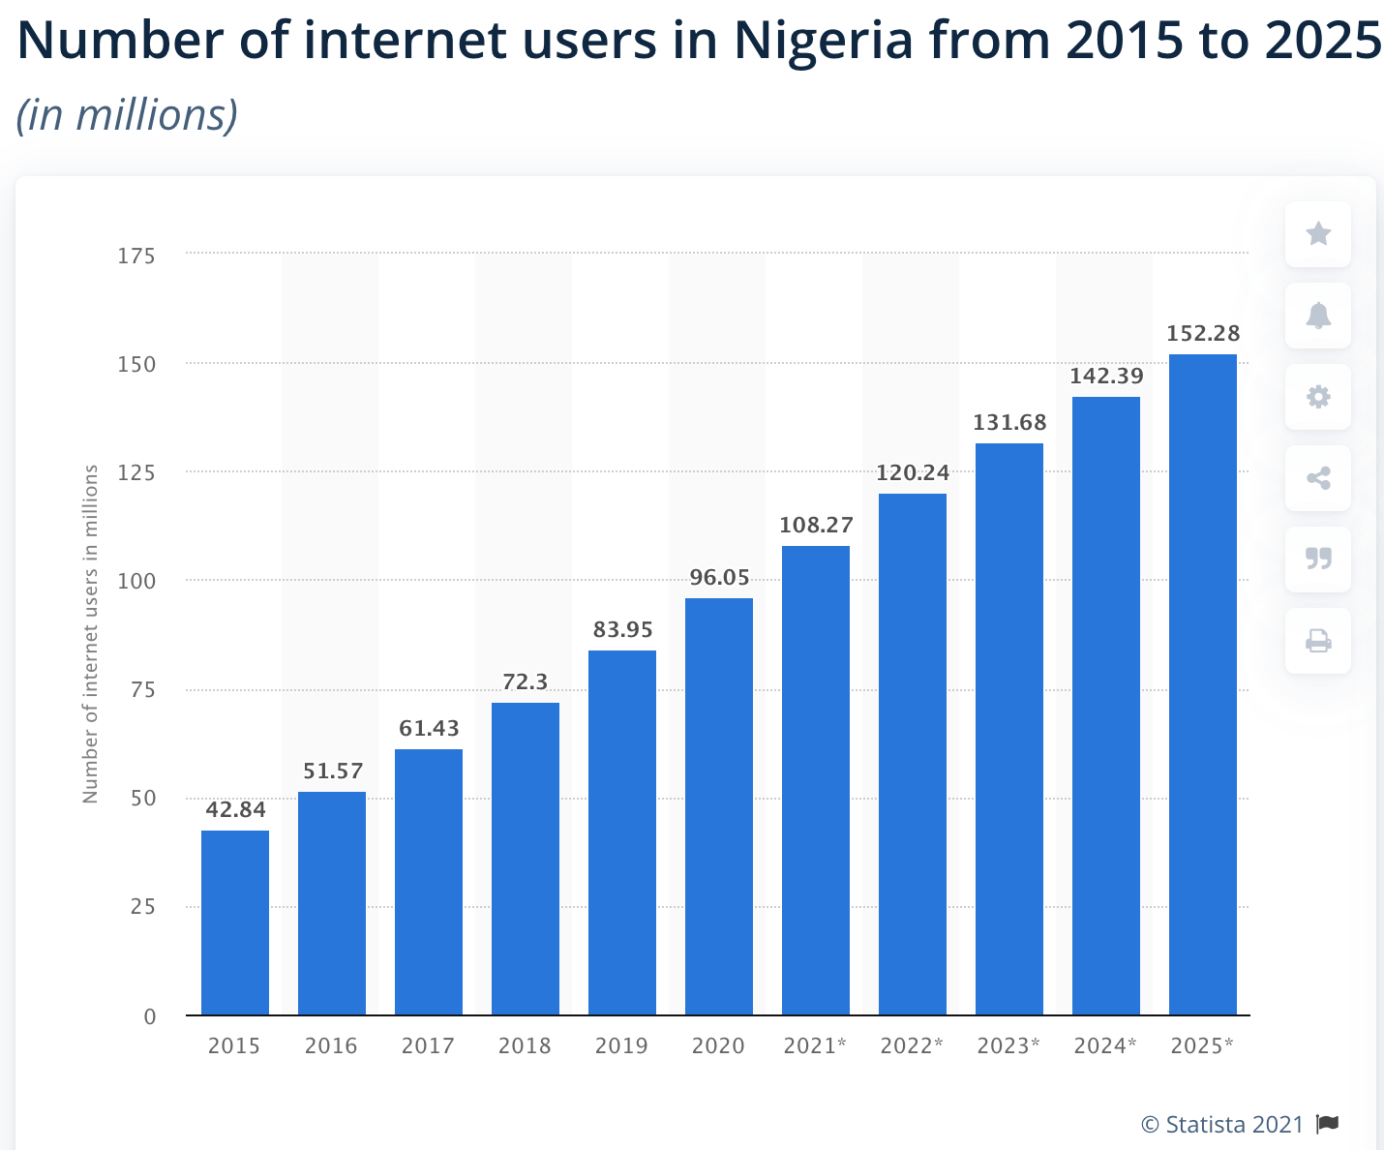
Source: Statist 2021

Exhibit 2: Ease Of Doing Business Index For Nigeria

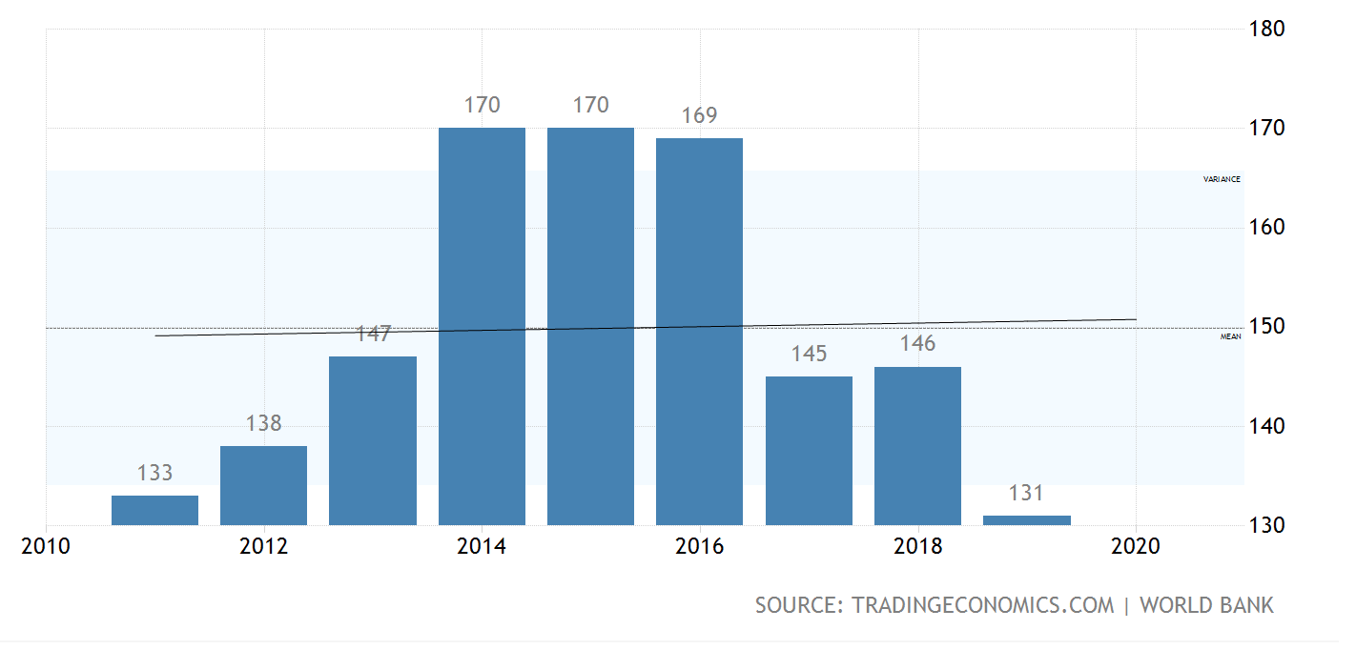
Source: TradingEconomics.com I World Bank

Exhibit 3: Sources Of Information Or Advice For MSMEs
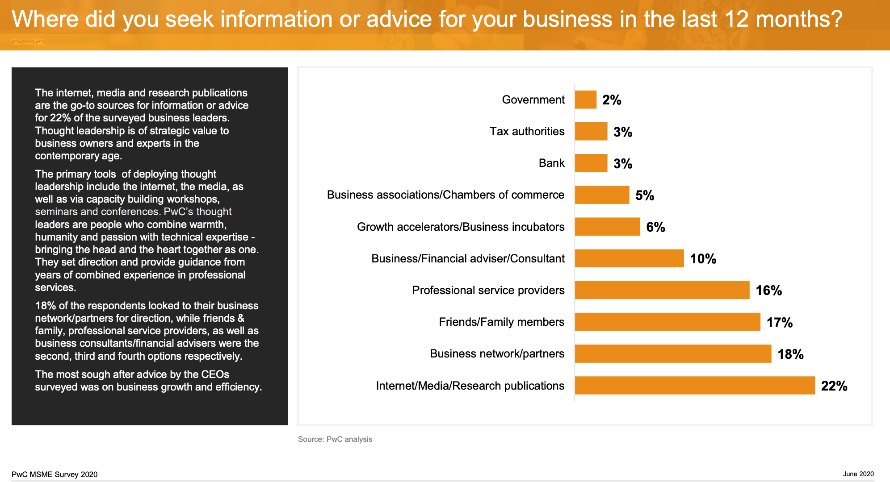
Source: Price Waterhouse Coopers MSME Survey June 2020

Exhibit 4: Insights On The MSME Sector In Nigeria
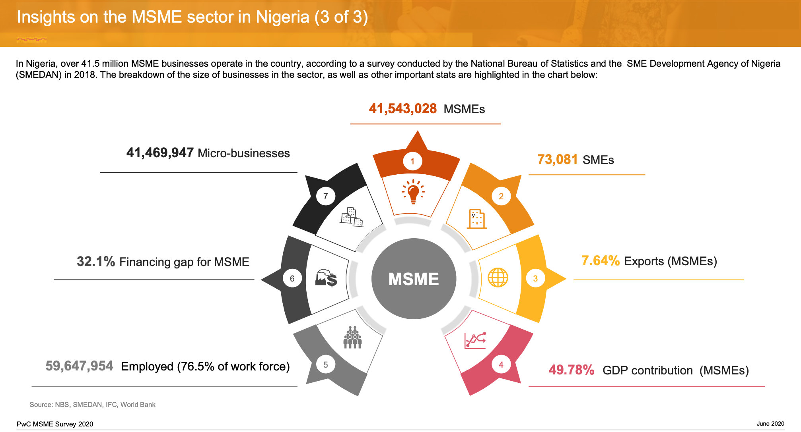
Source: Price Waterhouse Coopers MSME Survey June 2020
Exhibit 5: Key Processes For Kleos Africa
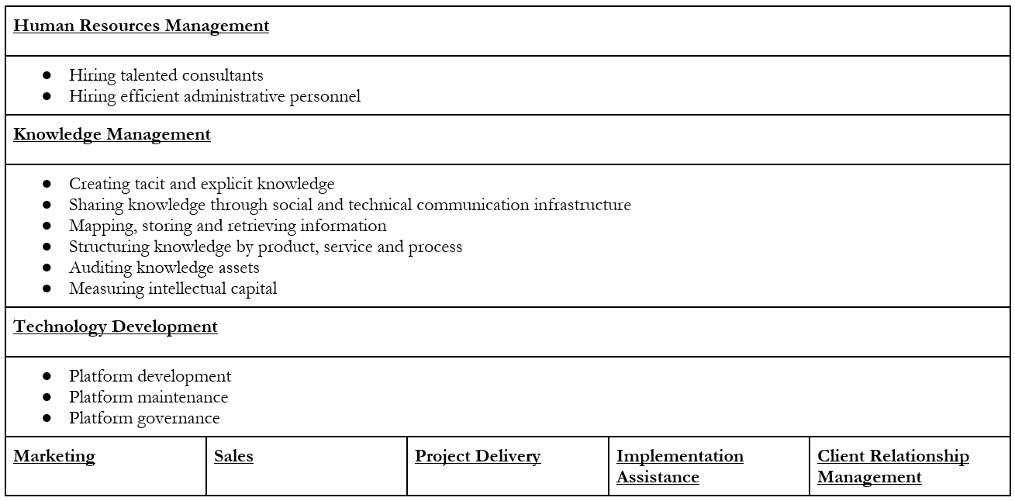
Source: Internal company documents

Exhibit 6: Kleos Value Chain
Operational Activity | Porter’s Value Chain | Kleos Advisory Value Chain
Operations-Sales Sequence | First produces and then sells | First sells and delivers
Operations | Delivery of a product | Delivery of a service
Distribution | Presence of inbound and outbound logistics | Absence of inbound and outbound logistics
Research and Development | Tangible products | Knowledge (Intangible products)
Procurement | Substantial | Inconsequential
Source: Internal Company Documents

Exhibit 7: Kleos Operational Flow

INPUTS
Funding
Technology platform
People (consultants and administrative personnel)
Strategic partnerships

ACTIVITIES
Business clinics
Digital marketing
Business consulting services
Training
Mentoring
Coaching
Research
Capital raising

OUTPUTS
Number of business plans
Business problems solved
New businesses established

OUTCOMES
Capital raised for new and established businesses
Increase in clients’ business revenue

VALUE ADD
Management consulting
Reduce youth unemployment
Empowerment of women entrepreneurs
Increase in jobs in the community
Encourage industry, enterprise and economic development
Alleviate poverty in Africa
Exhibit 8: Financial history*

 | 2017 | 2018 | 2019 | 2020
Revenue | 7,260,000 | 22,400,000 | 47,140,920 | 153,135,230
Direct costs | (1,000,000) | (11,118,630) | (27,913,500) | (106,132,000)
Gross profit | 6,260,000 | 11,281,380 | 19,227,420 | 47,003,220
Operating expenses | (4,787,500) | (10,327,650) | (18,557,060) | (33,481,240)
Finance cost | (178,380) | (290,280) | (344,8100) | (333,330)
Other income | 0 | 0 | 0 | 0
Profit before tax | 1,294,120 | 663,450 | 325,550 | 13,188,650
Income tax expense | (1,058,410) | (1,396,050) | (2,461,220) | (3,901,420)
Profit after tax | 235,700 | (732,600) | (2,135,670) | 9,287,230

*Figures are approximations

